Risk Profiler

Data By:

Area Scenario Training Download About Contact

**Scenario Name: Mw 9.0 Cascadia Interface**

Back to:

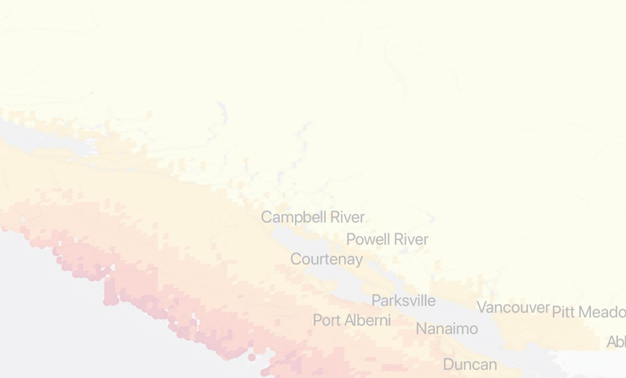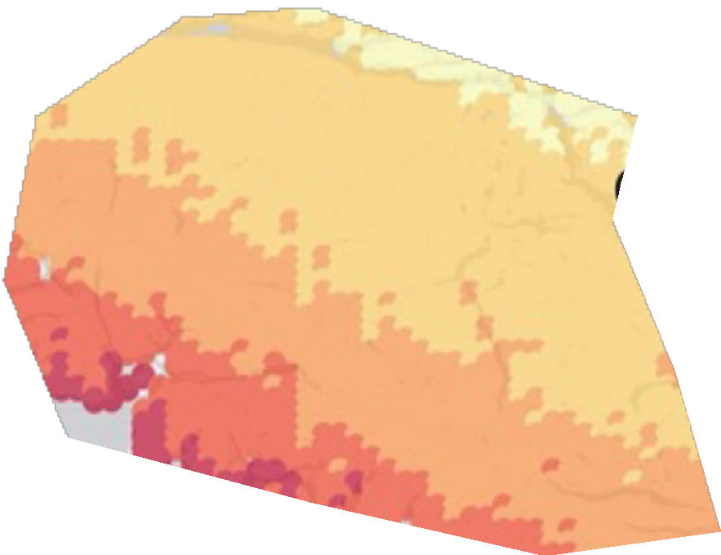

or View List

Result for Vancouver x-Return to Full Scenario

**+**

**-**

Go

Search By Metro Region or Municipality

Legend

**Summary: VANCOUVER**

Deaths

Damage Dollars

# 40,000

of 1,200,000

people

43

of 1000 buildings

# $43 Million

of $1.6 Billion





Footer

Back to:

Scenario Catalogue

Select indicator:

New? Take The Tour

Fatalities

Occupancy of The Buliding ?

Expand

Code Level of the Building ?

Expand

Construction Material ?

Expand